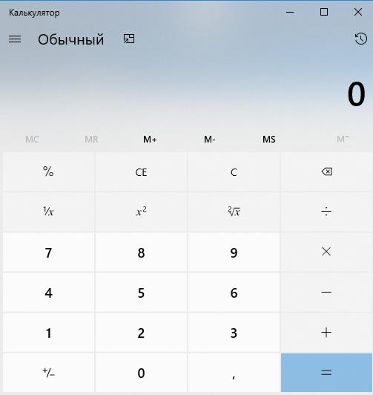

The set of functions of the calculator can be divided into two logical groups: **the logic of mathematical operations (**19 engineering functions) and **interaction with the operating** system (4 functions (interacting with the system, starting, stopping the application, working with the buffer)

Among the requirements for the application, we single out support for **one operating system with one main localization languages ​​and execution** (ENG)

Each application function is uniquely covered by one test. Tests, of course, include checking on test cases, checking for boundary values, etc.

Thus, for this example, the full coverage of functionality is determined by 23 test runs, of which 19 tests of mathematical functions are performed under one configuration and 4 tests of system functions under one test environment.

**Test cases**

1. Addition

2. Subtraction

3.Multiplication

4. Division

5. Square root of a number

6. Square

7. Clear Function

8. Add to Memory

etc.

**Do Test cases**

|  |  |  |  |
| --- | --- | --- | --- |
| **Number 0** | **Test Name: Clear Function** | | |
| **Fuction:** | Clear output field | | |
| **Action** | | **Expected Result** | **Test result**  **(passed/failed/blocked)** |
| PreConditions | |  | |
| open calculator application | | Calculator open correctly |  |
| Test Case Description: | |  | |
| 1)press 4 button  2)press 5 button  3) press C button | | **0** |  |
| PostConditions: | |  | |
| **Close application** | |  |  |

|  |  |  |  |
| --- | --- | --- | --- |
| **Number 1** | **Test Name: Addition** | | |
| **Fuction:** | Addition two numbers | | |
| **Action** | | **Expected Result** | **Test result**  **(passed/failed/blocked)** |
| PreConditions | |  | |
| open calculator application | | Calculator open correctly |  |
| Test Case Description: | |  | |
| 1)press 4 button  2) press plus button  3) enter 2 button  4) press equal button | | **6** |  |
| PostConditions: | |  | |
| **Close application** | |  |  |